***Report***

1. ***Parameters***
2. **Waveform parameters:**
   1. F chip=2.94kHz
   2. Pilots = 6 [sc]
   3. Modulation: 64QAM
3. **Coding:**
   1. Type: Reed-Solomon
   2. Rate=43/63
   3. Correction capability=10 bits out of 63 bits message
   4. Interleaving: yes
4. **Voice: by Alon Eilam, SIPL lab**
   1. Fsample=44.1ksps
   2. Quatization= 16 bits
   3. Codec compression rate=6.6/44.1
5. **Digital IF chain parameters:**
   1. Freconstruction=44.1ksps
   2. Fsample=44.1ksps
   3. Fc=17.5kHz
6. **Operational mode:**
   1. Time synchronization
   2. Frequency offset correction
   3. Channel estimation & Equalization
7. ***Data rate calculation:***
   1. Data Bits per Super Symbol=794 [bits] (error correction coding taken into consideration)
   2. Super Symbol duration= 104 [msec]
   3. **Data Rate~7.6 [kbps]** (packet preambles overhead not taken into consideration)
8. ***Simulations 1: Calibration***
   1. ***Conditions-***
      * 1. No Synchronization: delay is known
        2. Perfect channel knowledge
        3. Multipath: none
        4. Signal: general configuration- Frec=Fs=100ksps, BW=5kHz
   2. ***BER curves***: perfect match

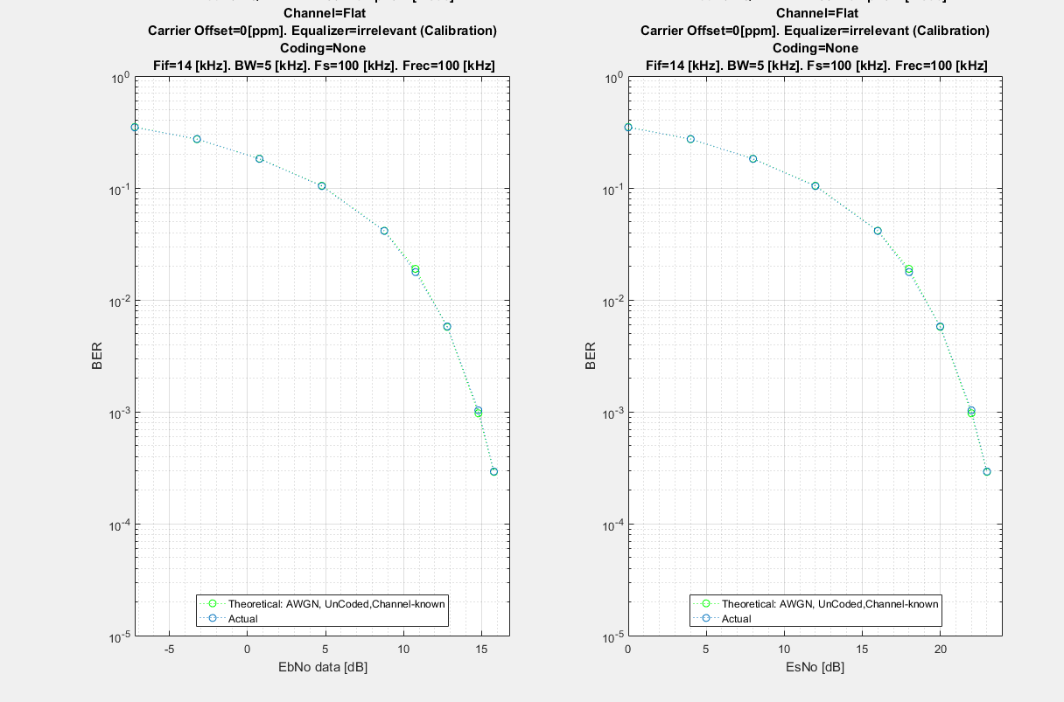

1. ***Simulation II: Flat channel, no Carrier offset:*** 
   1. ***Conditions-***
      1. Multipath: none
      2. Carrier offset: none
   2. ***Spectrum***
      1. ***No Noise***



* + 1. ***EsNo=30dB***



* 1. ***Scatter plot:***
     1. No noise



* + 1. EsNo=30dB



* 1. ***BER curves***:

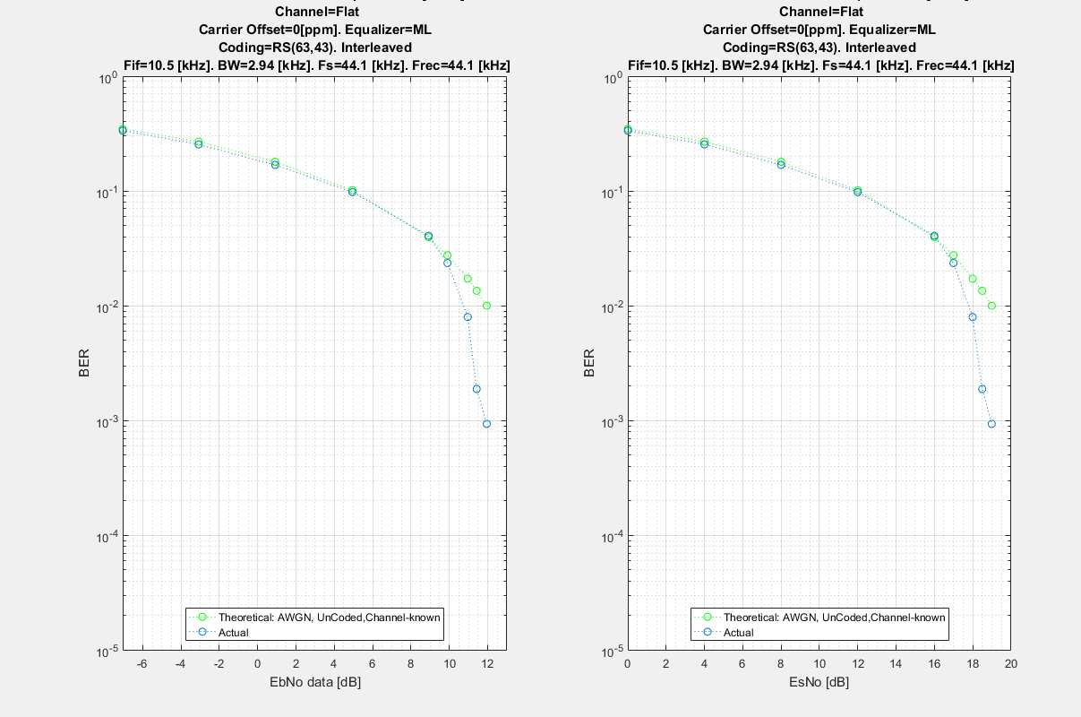

1. ***Multipath, No Carrier offset***
   1. Conditions:
      1. Multipath: 2 rays
         1. Delay spread= 2 [msec]
         2. Amplitude ratio=6 dB
      2. Carrier offset=0
   2. ***Spectrum***: EsNo=30 dB



* + 1. ***BER curves***:

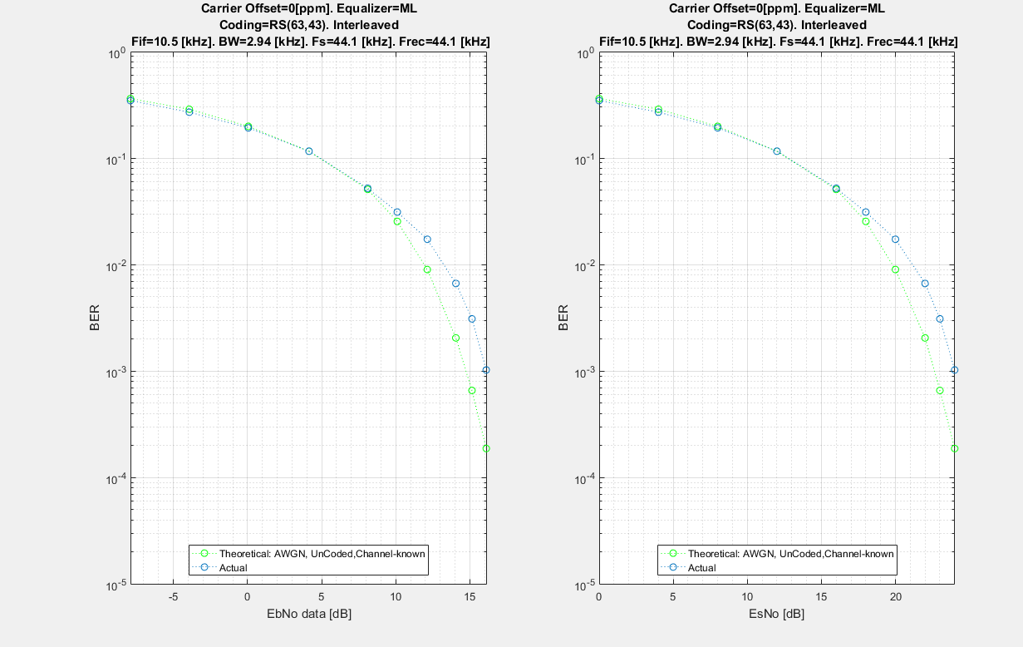

1. ***Flat, Carrier offset***
   1. ***Conditions-***
      1. Channel: flat
      2. Carrier offset=60ppm
   2. ***BER curves***:

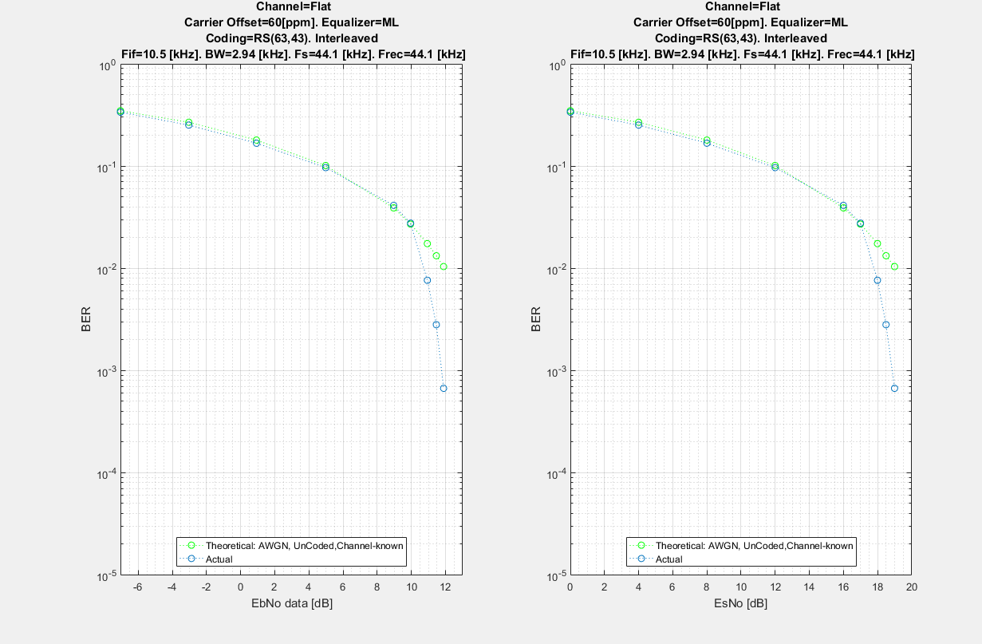

1. ***Multipath, Carrier offset***
   1. ***Conditions-***
      1. Multipath: 2 rays
         1. Delay spread= 2 [msec]
         2. Amplitude ratio=6 dB
      2. Carrier offset=60ppm
   2. ***BER curve***

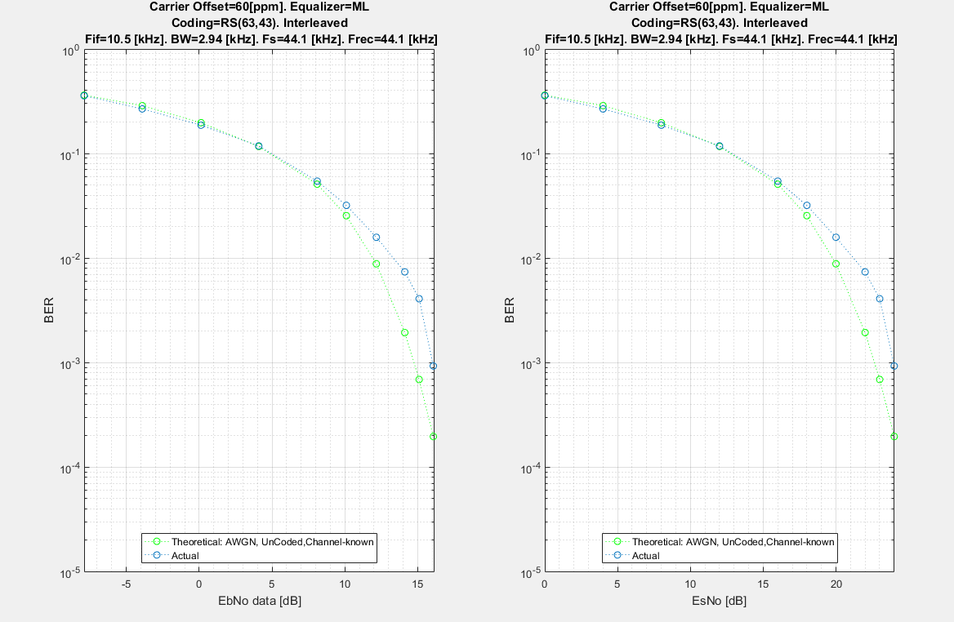

1. ***Room Model, no carrier offset***
   1. Room model: no noise, only multipath pattern
      1. Full

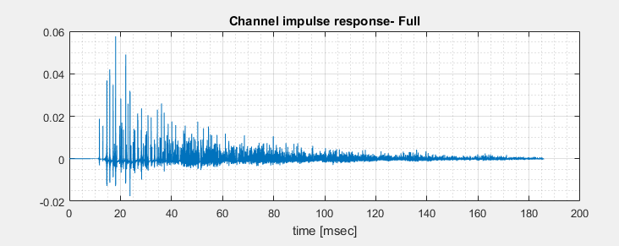

* + 1. Simulated: truncated from original to contain maximum energy and enable equalization in current OFDM configuration

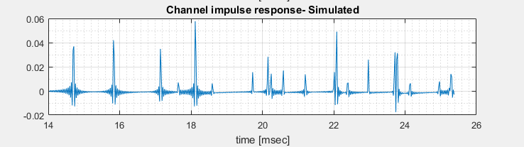

* 1. Spectrum



* 1. Results:
     1. LS equalizer: better on large memory channel



* + 1. ML equalizer: better on noisy channel

